Source Worksheet
Title:

Author:

Date:

What type of source is this (i.e. Primary, Secondary, Tertiary)?

Document Description:

GUIDING QUESTIONS
- Briefly describe what you saw/read in the document:

- Who is described/seen in the document?

- What was the purpose of the document (explain your argument)?

- What point of view is the document coming from (if applicable)?

- Can you connect this document with any others? If so, explain how

- Additional Information/Relevant Quote
Letter from King Leopold II of Belgium to Colonial Missionaries, 1883
"Reverends, Fathers and Dear Compatriots:
The task that is given to fulfill is very delicate and requires much tact. You will go certainly to evangelize, but your evangelization must inspire above all Belgium interests. Your principal objective in our mission in the Congo is never to teach the niggers to know God, this they know already. They speak and submit to a Mungu, one Nzambi, one Nzakomba, and what else I don’t know. They know that to kill, to sleep with someone else’s wife, to lie and to insult is bad. Have courage to admit it; you are not going to teach them what they know already. Your essential role is to facilitate the task of administrators and industrials, which means you will go to interpret the gospel in the way it will be the best to protect your interests in that part of the world. For these things, you have to keep watch on disinteresting our savages from the richness that is plenty [in their underground. To avoid that they get interested in it, and make you murderous] competition and dream one day to overthrow you.
Your knowledge of the gospel will allow you to find texts ordering, and encouraging your followers to love poverty, like “Happier are the poor because they will inherit the heaven" and, "It’s very difficult for the rich to enter the kingdom of God." You have to detach from them and make them disrespect everything which gives courage to affront us. I make reference to their Mystic System and their war fetish-warfare protection-which they pretend not to want to abandon, and you must do everything in your power to make it disappear.
Your action will be directed essentially to the younger ones, for they won’t revolt when the recommendation of the priest is contradictory to their parent’s teachings. The children have to learn to obey what the missionary recommends, who is the father of their soul. You must singularly insist on their total submission and obedience, avoid developing the spirit in the schools, teach students to read and not to reason. There, dear patriots, are some of the principles that you must apply. You will find many other books, which will be given to you at the end of this conference. Evangelize the niggers so that they stay forever in submission to the white colonialists, so they never revolt against the restraints they are undergoing. Recite every day-"Happy are those who are weeping because the kingdom of God is for them."
Convert always the blacks by using the whip. Keep their women in nine months of submission to work freely for us. Force them to pay you in sign of recognition-goats, chicken or eggs-every time you visit their villages. And make sure that niggers never become rich. Sing every day that it’s impossible for the rich to enter heaven. Make them pay tax each week at Sunday mass. Use the money supposed for the poor, to build flourishing business centers. Institute a confessional system, which allows you to be good detectives denouncing any black that has a different consciousness contrary to that of the decision-maker. Teach the niggers to forget their heroes and to adore only ours. Never present a chair to a black that comes to visit you. Don’t give him more than one cigarette. Never invite him for dinner even if he gives you a chicken every time you arrive at his house.

Letter from King Leopold II of Belgium to Minister Beernaert on the Congo, July 3, 1890
Leopold II was "King of the Belgians" (ruled 1865-1909) and "Sovereign-King of the Congo Free State," at the time (19th century) the largest swath of African land under the control of a colonial power (one million square miles). Leopold, one of the most cruel and imperious 19th century European heads of state, ruled the Congo as his own personal fiefdom, though he never set foot there. Joseph Conrad's famous novella Heart of Darkness (which inspired the movie Apocalypse Now, among other treatments) perhaps best captured the abominable inhumanity practiced in the Congo. First ivory and then the rubber trade greatly augmented the king's already considerable personal wealth. Under withering world-wide indictment over his treatment of the native population, Leopold was forced to sell the Congo to the Belgian government in 1908.
Dear Minister,
I have never ceased to call the attention of my countrymen to the need to turn our view toward overseas lands.
History teaches that countries with small territories have a moral and material interest in extending their influence beyond their narrow borders. Greece founded opulent cities, bastions of arts and civilization, on the shores of the Mediterranean. Later, Venice built its grandeur on its maritime and commercial relations no less than on its political success. The Netherlands have 30 million subjects in the Indies who exchange tropical products for the products of the mother country.
It is in serving the cause of humanity and progress that peoples of the second rank appear as useful members of the great family of nations. A manufacturing and commercial nation like ours, more than any other, must do its best to secure opportunities for all its workers, whether intellectual, capitalist, or manual.
These patriotic preoccupations dominated my life. It is they that caused the creation of the African effort.
My pains were not sterile: a young and vast State, led from Brussels, has peacefully taken its place in the sun, thanks to the kind support of the powers which have applauded its beginnings. Belgians administer it, while other compatriots, more numerous every day, are already making a profit on their capital.
The immense river system of the Upper Congo opens the way for our efforts for rapid and economical ways of communication that will allow us to penetrate directly into the center of the African continent. The building of the railroad in the cataract area, assured from now on thanks to the recent vote of the legislature, will notably increase the ease of access. Under these conditions, a great future is reserved for the Congo, whose immense value will soon shine out to all eyes.
Soon after that memorable act, I thought it my duty, when death will come to strike me, to make it easy for Belgium to profit from my work, as well as that of those who helped me to found and direct it and to whom I give thanks here once again. I thus made, as Sovereign of the Congo Free State, the will that I am sending you; I will request that you communicate it to the legislative Chambers at what seems to you the most opportune moment.
The beginning of enterprises such as those that have so preoccupied me is difficult and onerous. I insisted on bearing the charges. A King, to give service to his country, must not fear to conceive and pursue the realization of a project so adventurous in appearance. The riches of a Sovereign consist of public prosperity. That alone can appear to his eyes as an enviable treasure, which he should try constantly to build up.
Until the day of my death, I will continue with the same thoughts of national interest that have guided me until now, to direct and sustain our African efforts, but if, without waiting for that date, it makes sense for the country to contract closer ties with my Congo possessions, I would not hesitate to make them available to it, I would be happy, while I am alive, to see it in full benefit towards the Chambers as towards the Government for the aid that they gave to me on several occasions in this creation.
I do not think I am mistaken in affirming that Belgium will gain genuine advantages and will see opening before her, on a new continent, happy and wide perspectives.
Believe me, dear Minister,
Your very devoted,
Leopold.
Translated from the French by Katherine Bryant.

THE TRYST.
"It is stated that the Pungwé route to Mashonaland has been again closed by the Portuguese Authorities."—Reuter, May 24.
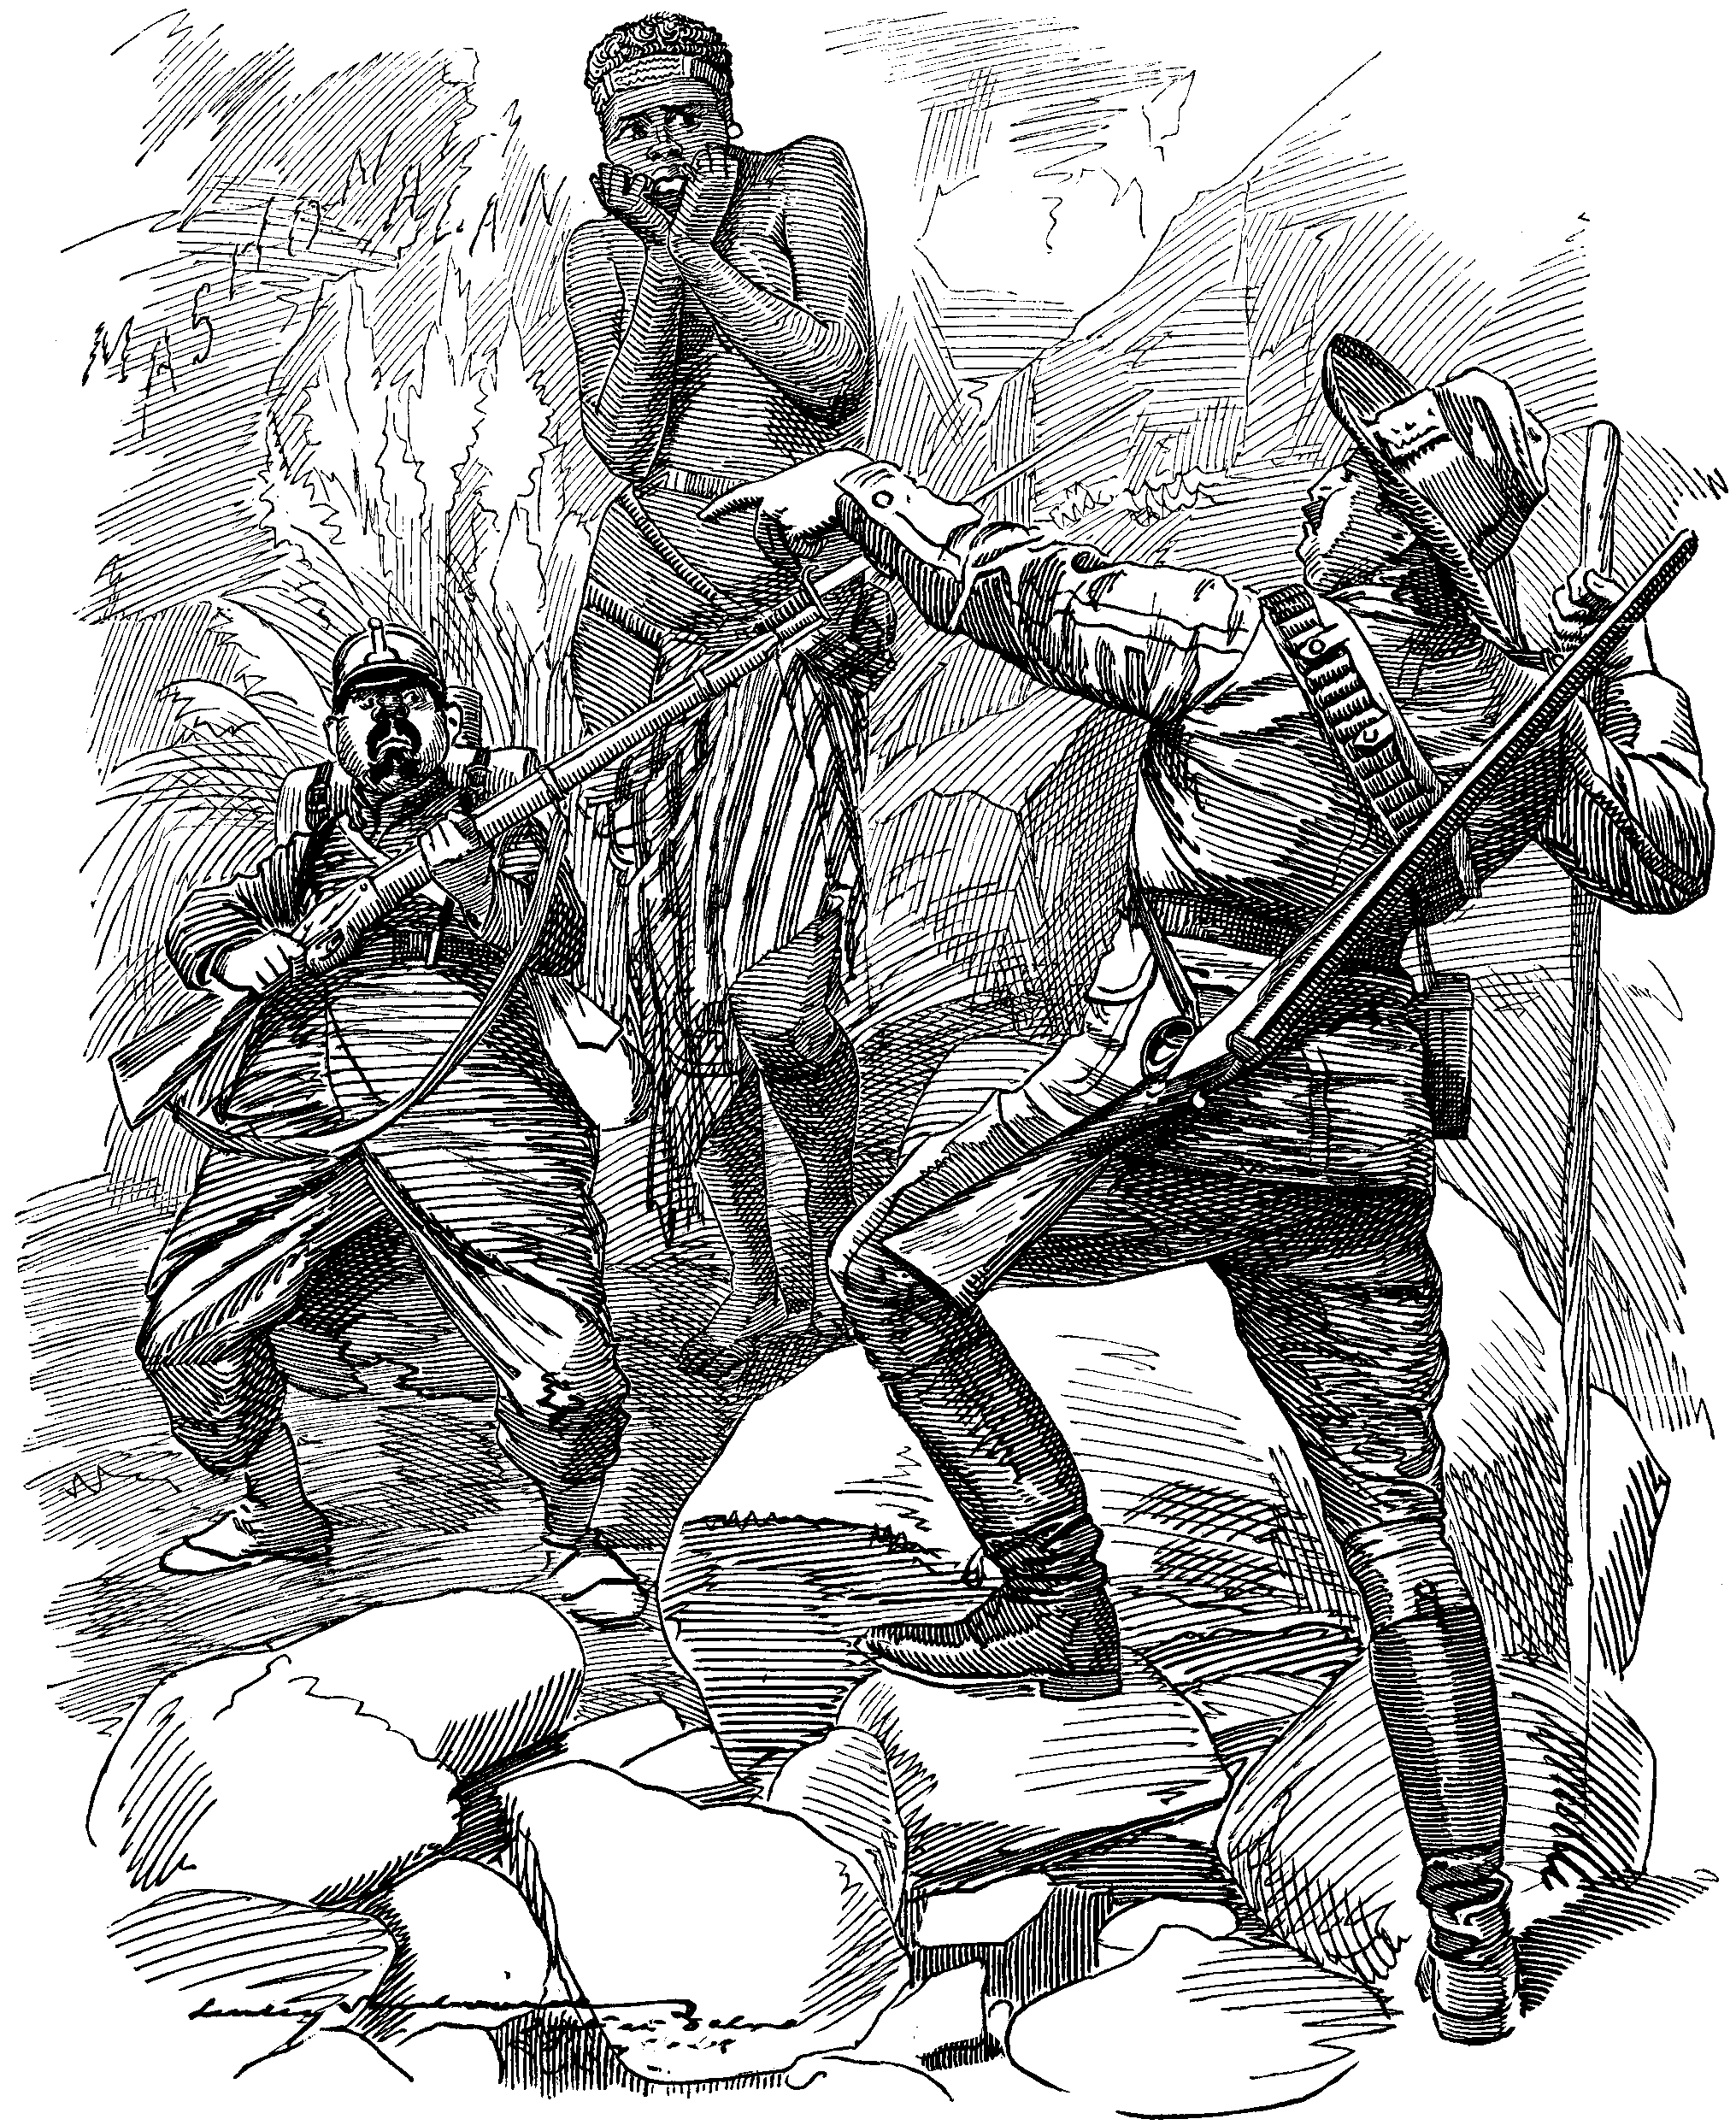

Cecil Rhodes, "YOU CLEAR OUT! SHE'S MY 'MASH!'"

Now then, young Obstructive, still playing the sentry,
Where nobody wants you to watch or mount guard?
Are you to rule everyone's exit and entry?
Clear out, my young friend, or with you 'twill go hard.
You Portuguese Tappertit, turn it up, do!
D'ye think I'll be stopped by a monkey like you?
My Mash, that young woman! Will you bar our meeting?
We're sweethearts. Will you interfere with our tryst?
You pert whippersnapper, my sable-skinned sweeting
My masculine wooing's too wise to resist.
Shall RHODES be cut out by a small Portuguese,
With a gun and a swagger? Pooh! Fiddle-de-dee!
We've put up too long with your pranks, my fine fellow,
Because of your size, upon which you presume.
Oh, it's no use to twirl your moustache and look yellow!
Mean having that gal, howsoever you fume.
You'd better behave yourself, boy, or no doubt
Before very long we shall clean you right out.
Look at home, keep your own ways a little bit clearer,
And don't go a-blocking up other folks' roads.
Eh? You warn me off her? I mustn't come nearer?
Ha, ha! My good-nature your impudence goads.
Clear out, whilst you're safe, you young shrimp! Don't be rash!
For I shan't let you come between me and my Mash!
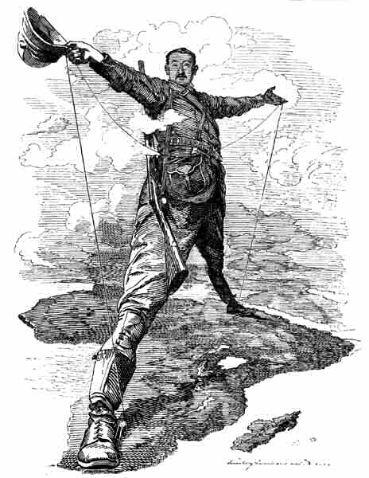

Imperialism: Sample of Native Treaty
When the European powers (particularly Britain, Germany, France) 'scrambled' for parts of Africa in the last quarter of the nineteenth century, a common device for securing territories was by so-called 'treaty', often a ready-made blank document carried by colonial agents presented to local rulers for signing. Trickery, false promises and intimidation were the rule during this period in which virtually the entire continent was carved up in the interests of the powers. The following is such a document, with appropriate blank spaces, as employed by agents of the British Royal Niger Company.
- We, the undersigned Chiefs of . . . . . . . , with the view of bettering the condition of our country and people, do this day cede to the Royal Niger Company (Chartered and Limited), for ever, the whole of our territory extending from ....................
- We also give to the said Royal Niger Company (Chartered and Limited) full power to settle all native disputes arising from any cause whatever, and we pledge ourselves not to enter into any war with other tribes without the sanction of the said Royal Niger Company (Chartered and Limited).
- We understand that the said Royal Niger Company (Chartered and Limited) have full power to mine, farm, and build in any portion of our country.
- We bind ourselves not to have any intercourse[i.e., transactions or communications] with any strangers or foreigners except through the said Royal Niger Company (Chartered and Limited).
- In consideration of the foregoing, the said Royal Niger Company (Chartered and Limited) bind themselves not to interfere with any of the native laws or customs of the country, consistently with the maintenance of order and good government
- The said Royal Niger Company (Chartered and Limited) agree to pay native owners of land a reasonable amount for any portion they may require.
- The said Royal Niger Company (Chartered and Limited) bind themselves to protect the said Chiefs from the attacks of any neighbouring aggressive tribes.
- The said Royal Niger Company (Chartered and Limited) also agree to pay the said Chiefs ..................... native value.
- We, the undersigned witnesses, do hereby solemnly declare that the ..................... Chiefs whose names are placed opposite their respective crosses have in our presence affixed their crosses of their own free will and consent, and that the said ...................... has in our presence affixed his signature.
Done in triplicate at ....................... this ..................day of ................. , 188. .
Declaration by Interpreter.
I, ...................... of .................. , do hereby solemnly declare that I am well acquainted with the language of the .......................... country, and that of the ........day of ......... , 188. , I truly and faithfully explained the above Agreement to all the Chiefs present, and that they understood its meaning.

Modern History Sourcebook:
Jules Ferry (1832-1893):
On French Colonial Expansion

Ferry was twice prime minister of France, from [1880-1881, 1883-1885]. He is especially remembered for championing laws that removed Catholic influence from most education in France and for promoting a vast extension of the French colonial empire.
The policy of colonial expansion is a political and economic system ... that can be connected to three sets of ideas: economic ideas; the most far-reaching ideas of civilization; and ideas of a political and patriotic sort.
In the area of economics, I am placing before you, with the support of some statistics, the considerations that justify the policy of colonial expansion, as seen from the perspective of a need, felt more and more urgently by the industrialized population of Europe and especially the people of our rich and hardworking country of France: the need for outlets [for exports]. Is this a fantasy? Is this a concern [that can wait] for the future? Or is this not a pressing need, one may say a crying need, of our industrial population? I merely express in a general way what each one of you can see for himself in the various parts of France. Yes, what our major industries [textiles, etc.], irrevocably steered by the treaties of 18601 into exports, lack more and more are outlets. Why? Because next door Germany is setting up trade barriers; because across the ocean the United States of America have become protectionists, and extreme protectionists at that; because not only are these great markets ... shrinking, becoming more and more difficult of access, but these great states are beginning to pour into our own markets products not seen there before. This is true not only for our agriculture, which has been so sorely tried ... and for which competition is no longer limited to the circle of large European states .... Today, as you know, competition, the law of supply and demand, freedom of trade, the effects of speculation, all radiate in a circle that reaches to the ends of the earth .... That is a great complication, a great economic difficulty; ... an extremely serious problem. It is so serious, gentlemen, so acute, that the least informed persons must already glimpse, foresee, and take precautions against the time when the great South American market that has, in a manner of speaking, belonged to us forever will be disputed and perhaps taken away from us by North American products. Nothing is more serious; there can be no graver social problem; and these matters are linked intimately to colonial policy.
Gentlemen, we must speak more loudly and more honestly! We must say openly that indeed the higher races have a right over the lower races ....
I repeat, that the superior races have a right because they have a duty. They have the duty to civilize the inferior races .... In the history of earlier centuries these duties, gentlemen, have often been misunderstood; and certainly when the Spanish soldiers and explorers introduced slavery into Central America, they did not fulfill their duty as men of a higher race .... But, in our time, I maintain that European nations acquit themselves with generosity, with grandeur, and with sincerity of this superior civilizing duty.
I say that French colonial policy, the policy of colonial expansion, the policy that has taken us under the Empire [the Second Empire, of Napoleon 1111, to Saigon, to Indochina [Vietnam], that has led us to Tunisia, to Madagascar-I say that this policy of colonial expansion was inspired by... the fact that a navy such as ours cannot do without safe harbors, defenses, supply centers on the high seas .... Are you unaware of this? Look at a map of the world.
Gentlemen, these are considerations that merit the full attention of patriots. The conditions of naval warfare have greatly changed .... At present, as you know, a warship, however perfect its design, cannot carry more than two weeks' supply of coal; and a vessel without coal is a wreck on the high seas, abandoned to the first occupier. Hence the need to have places of supply, shelters, ports for defense and provisioning.... And that is why we needed Tunisia; that is why we needed Saigon and Indochina; that is why we need Madagascar... and why we shall never leave them! ... Gentlemen, in Europe such as it is today, in this competition of the many rivals we see rising up around us, some by military or naval improvements, others by the prodigious development of a constantly growing population; in a Europe, or rather in a universe thus constituted, a policy of withdrawal or abstention is simply the high road to decadence! In our time nations are great only through the activity they deploy; it is not by spreading the peaceable light of their institutions ... that they are great, in the present day.
Spreading light without acting, without taking part in the affairs of the world, keeping out of all European alliances and seeing as a trap, an adventure, all expansion into Africa or the Orient-for a great nation to live this way, believe me, is to abdicate and, in less time than you may think, to sink from the first rank to the third and fourth.

Source:
From Jules François Camille Ferry, "Speech Before the French Chamber of Deputies, March 28, 1884," Discours et Opinions de Jules Ferry, ed. Paul Robiquet (Paris: Armand Colin & Cie., 1897), -1. 5, pp. 199-201, 210-11, 215-18. Translated by Ruth Kleinman in Brooklyn College Core Four Sourcebook
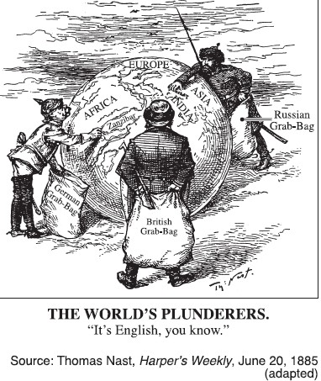

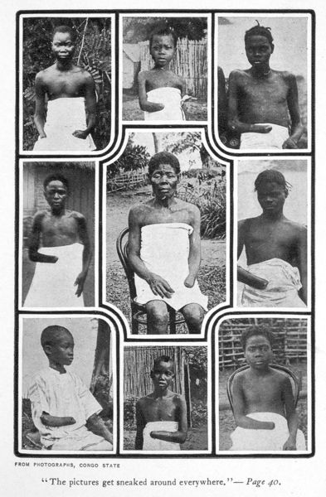

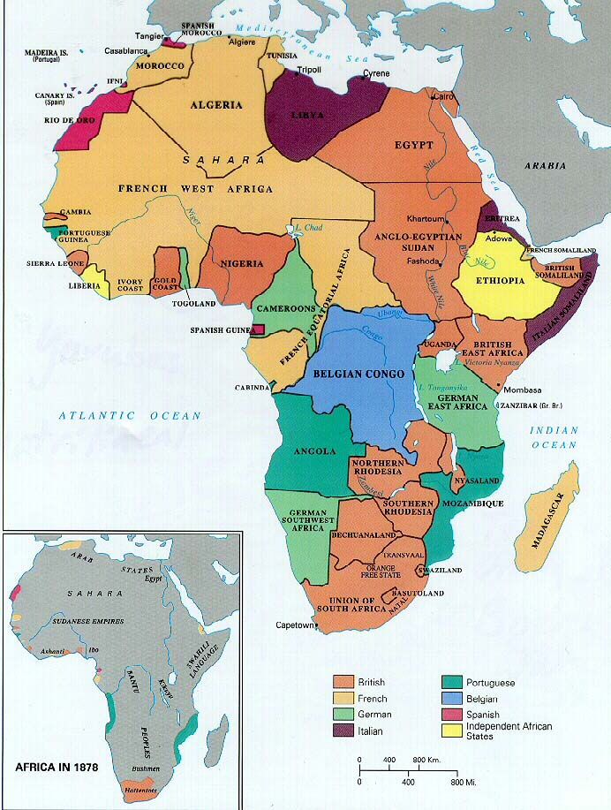

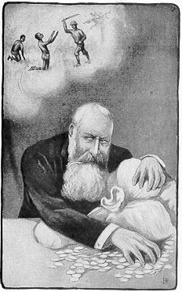

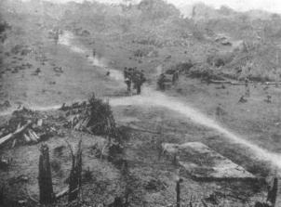
Rubber Plantation in the Congo Free State

